ACTSEA-2011
Third International Symposium on Advanced Ceramics and Technology for Sustainable Energy Applications
Oct. 30 – Nov. 2, 2011
Howard Beach Resort Kenting. Hengchun Town, Pingtung, Taiwan

Abstract Submission Form

Presentation type: Oral Poster Title: Prof. Dr. Mr. Ms
Name of Corresponding Author:
Affiliation:

Address:

Phone No. Fax No.
Email address:

Title of the Paper:

Authors:

(Indicate presenting author with # symbol)

Pictures of Corresponding and Presenting Authors
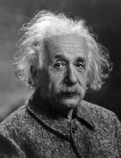
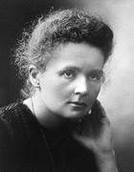

Albert Einstein Marie Curie
(Name of corresponding author) (Name of presenting author)
Please email the submission form and abstract to:

Professor Jay Shieh
Department of Materials Science and Engineering, National Taiwan University
Taipei, TAIWAN
E-mail: jayshieh@ntu.edu.tw

Template for 2-page extended abstract is given on the next page.
Instructions for Preparation of 2-Page Extended Abstract for ACTSEA-2011

First author’s name¹ (initials, followed by last name), Second author’s name² (initials, followed by last name), Third author’s name³∗ (initials, followed by last name)

¹ Affiliation of first author, country
² Affiliation of second author, country
³ Affiliation of third author, country

Keywords: three to five keywords

Introduction
This is where the extended abstract should be placed. The abstract should be no longer than 2 pages and supplied in MS Word format. PDF is NOT acceptable. Please use page size A4 (210 × 297 mm or 8.27 × 11.69 in), with top, bottom, left and right margins of 30 mm each.
The title of the abstract (in title caps) is to be in Times New Roman, point 12, bold. The authors’ names and affiliations are to be in Times New Roman, point 10, italics. Please underline the presenting author. Author forenames/surnames should be explicit: to minimize ambiguity it is recommended that first initials and last (family) name are used [1]. The body text for the abstract should be in Times New Roman, point 12, single line spacing. Refereneces should be in Times New Roman, point 10.

Results and Discussion
Please start a new section with one line spacing. All paragraphs must be fully justified. The abstract must be written in English. SI-units should be used [2].

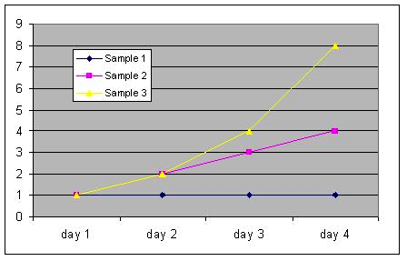
Fig. 1. One to two tables or figures can be inserted into the text.

Conclusions
The organizing committee reserves the right to return or reject abstracts to author(s) who do not comply strictly with the format instructions given above.

References

[1] G.W. Scherer, J. Am. Ceram. Soc., 73, 3-14 (1990).
[2] J. Shieh, K.C. Wu, and C.S. Chen, Acta Mater., 55, 3081-3087 (2007).

[3] H.R. Baumgartner and B.R. Ressing, pp. 3-16 in Ceramic Transactions, Vol. 2, Silicon Carbide '87. Edited by J.D. Cawley and C.F. Semler. American Ceramic Society, Westerville, OH, 1989.
[4] A. Moyer, N. Hughes, and R. Winterton, pp. 117-39 in Materials Research Society Symposium Proceedings, Vol. 73, Better Ceramics through Chemistry 11. Edited by C. Brinker, D. Clark, and D. Ulrich. Materials Research Society, Pittsburgh, PA, 1986.

 Corresponding author. Phone: Fax: E-mail:

